In Java's Spring Framework, a web service can simultaneously produce both JSON and XML responses using content negotiation. Spring provides tools to determine the desired response format (JSON or XML) based on client requests, such as the Accept header, query parameters, or file extensions.

Steps to Produce JSON and XML Simultaneously
- Add Dependencies Ensure your project includes dependencies for both JSON and XML message converters. For example, in a Maven-based Spring project:
Maven Dependencies
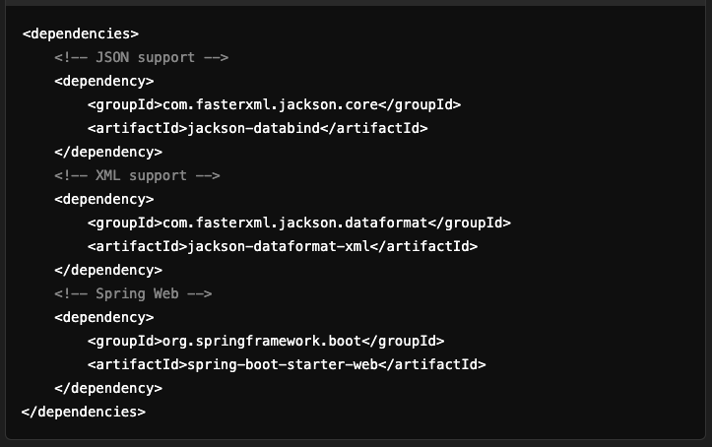

- Configure Your Spring Boot Application
Spring Boot auto-configures message converters for both JSON and XML if the necessary dependencies are present. These message converters handle the serialization of Java objects into JSON or XML, depending on the request.

- Define a Model
Create a POJO to represent your data.
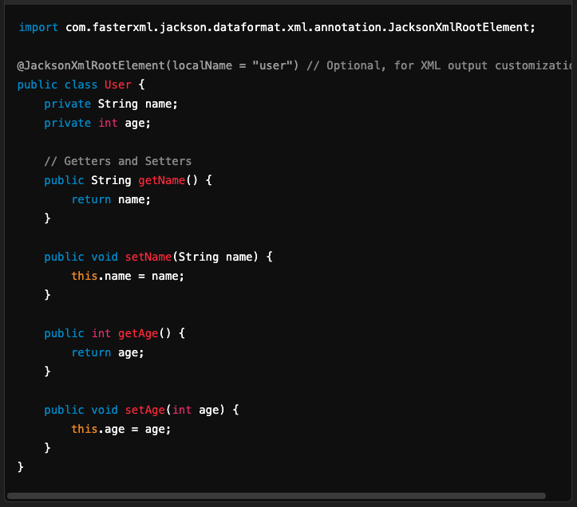

- Create a Controller
Define a REST controller to handle HTTP requests and respond with JSON or XML based on the Accept header.
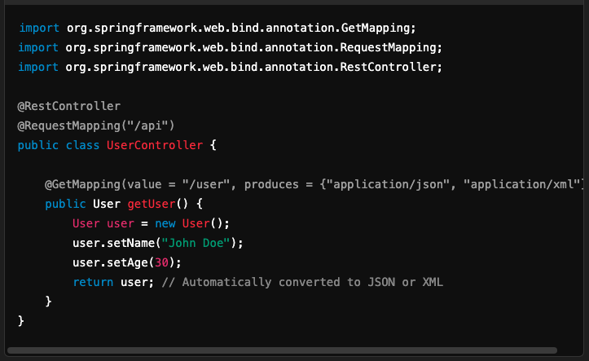

- How It Works
- Content Negotiation:
  - The client specifies the desired format using the Accept header.
    - For JSON: Accept: application/json
    - For XML: Accept: application/xml
  - Spring uses the appropriate HttpMessageConverter to serialize the response.

- Testing the Endpoint
- Request for JSON:
- Response:
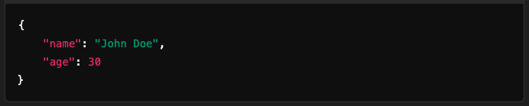
- Request for XML:
- Response:
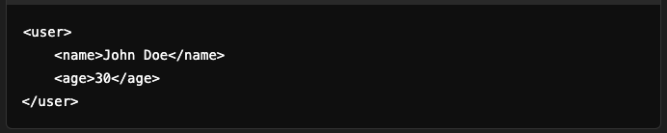

Advanced Customization
- Customizing Message Converters If you need custom serialization or additional converters, you can configure them in WebMvcConfigurer.
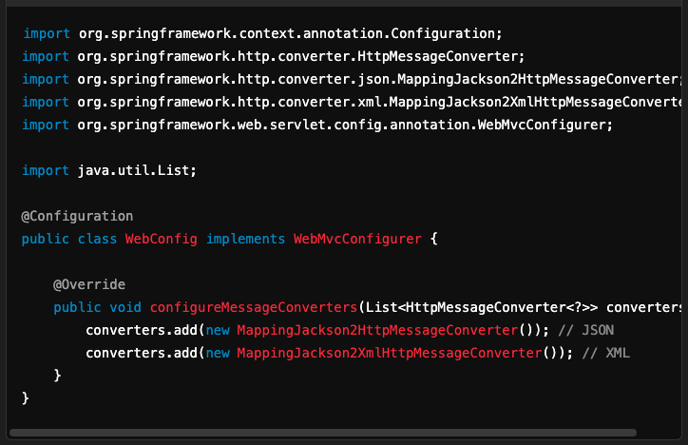

- Support Query Parameter-Based Negotiation Add query parameter support by configuring ContentNegotiationManager.
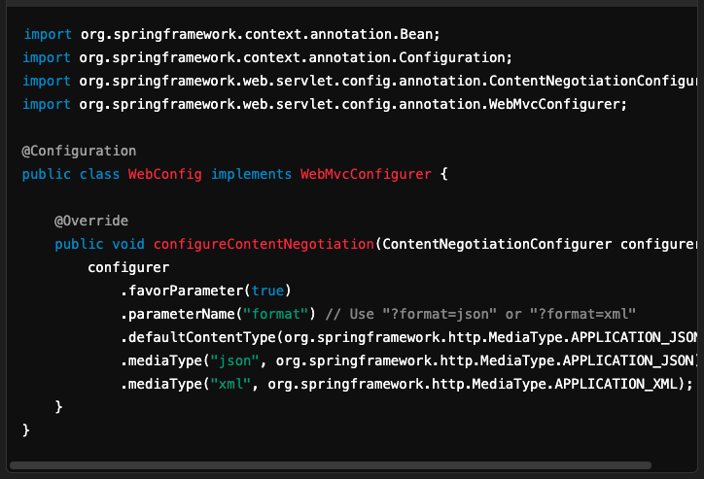

Conclusion
By using Spring's built-in content negotiation and message converters, you can easily produce both JSON and XML outputs from the same endpoint. Customizing converters or content negotiation settings allows you to meet specific application needs.

